

**MATHEMATICAL MODELLING**

TIDAL WAVE SIMULATION



**LECTURER :**

Prof. Dr. Basuki Widodo, M.Sc

**ARRANGED BY :**

|  |  |
| --- | --- |
| VENANSIUS RYAN TJAHJONO | (06111540000043) |
| TITIN JUNIK AMBARWATI | (06111540000065) |
| VIRA DIANA ULNAZILLA | (06111540000067) |
| SUMIHAR CHRISTIAN N.S | (06111540000115) |

MATHEMATICS DEPARTMENT

FACULTY OF MATHEMATICS COMPUTATION AND DATA SCIENCES

INSTITUT TEKNOLOGI SEPULUH NOPEMBER

SURABAYA

2018

1. **ASSIGNMENT DESCRIPTION**

The objective of this assignment is to simulate the tidal wave in Matlab. We first consider the value of time as 1 and input some value of other variable (length of wave, height of wave, initial condition for position, and initial position for speed). Each value given to those variable is to find out how big their influence to the tidal wave.

**B. MATLAB SOURCE CODE**

L = str2num(get(handles.edit2,'String'));

u0 = str2num(get(handles.edit3,'String'));

ut0 = str2num(get(handles.edit4,'String'));

h = str2num(get(handles.edit5,'String'));

x=1;

t = 0:0.01:1;

g = 9.8;

n = [1 2 3];

an = zeros([1 3]);

bn = zeros([1 3]);

omega = zeros([1 3]);

u = zeros([3 length(t)]);

for i = 1:1:3

omega(i) = n(i)*pi*sqrt(g*h)/L;

bn(i) = u0/sin(n(i)*pi*x/L);

an(i) = ut0/(omega(i)*sin(n(i)*pi*x/L));

for j = 1:1:length(t)

u(i,j) = sin(n(i).*pi*x/L).*(an(i).*sin(omega(i).*t(j))+bn(i).*cos(omega(i).*t(j)));

end

end

axes(handles.axes1);

for i = 1:1:3

plot(t,u(i,:)); hold on;

end

cla(handles.axes1);

for i = 1:1:3

plot(t,u(i,:), 'linewidth', 1.15); hold on;

end

cla(handles.axes1);

for i = 1:1:3

plot(t,u(i,:), 'linewidth', 1.15); hold on;

end

legend('n = 1','n = 2','n = 3');

xlabel('TIME','FontSize',10,'FontWeight','bold','Color','k');

ylabel('DEFLECTION','FontSize',10,'FontWeight','bold','Color','k');

handles.axes1.GridColor = 'k';

[x,t] = meshgrid(0:0.01:1);

k=1;

axes(handles.axes4);

title('n=1');

z =sin(k*pi.*x/L).*(an(k).*sin(omega(k).*t)+bn(k).*cos(omega(k)*t));

mesh(x,t,z);

k=2;

axes(handles.axes5);

legend('n=2');

z =sin(k*pi.*x/L).*(an(k).*sin(omega(k).*t)+bn(k).*cos(omega(k)*t));

mesh(x,t,z);

k=3;

axes(handles.axes6);

title('n=3');

z =sin(k*pi.*x/L).*(an(k).*sin(omega(k).*t)+bn(k).*cos(omega(k)*t));

mesh(x,t,z);

set(handles.edit7,'String',toc);

1. 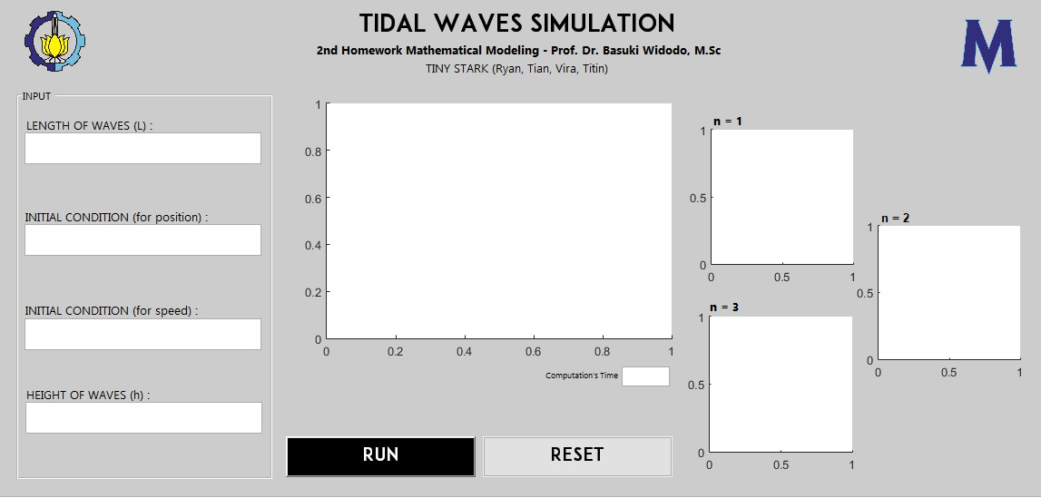**MATLAB SIMULATION**

*Figure 1. Interface of Tidal Wave Simulation*

1. **Tidal Wave Simulation with Different Length of Wave**

Assume that the initial condition for position is $1,$ initial condition for speed is $1$, and height of wave is $5$. .

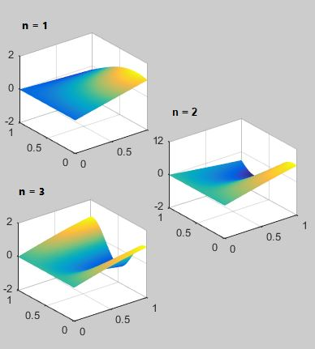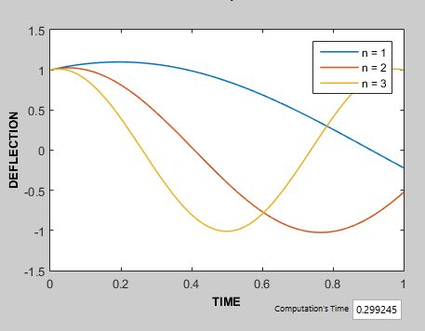

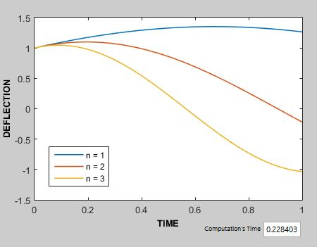*Figure 2. Tidal Wave Simulation with Length is $10$*

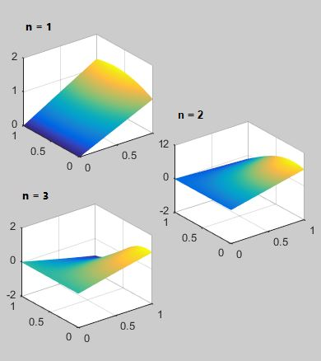

*Figure 3. Tidal Wave Simulation with Length is $20$*

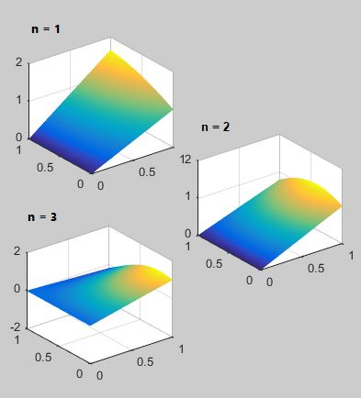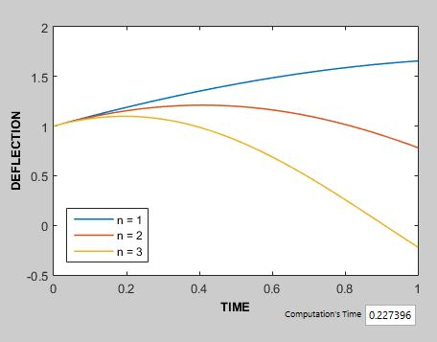

*Figure 4. Tidal Wave Simulation with Length is $30$*

1. **Tidal Wave Simulation with Different Initial Condition for Position**

Assume that length of wave is $10,$ initial condition for speed is $1$, and height of wave is $5$.

*Figure 5. Tidal Wave Simulation with Initial Condition for Position is $-10$*

*Figure 6. Tidal Wave Simulation with Initial Condition for Position is $0$*

*Figure 7. Tidal Wave Simulation with Initial Condition for Position is $10$*

